=== Comparison for du ===  
 Metric Vanilla EVP Difference % Difference  
 NumQueries 1010.0 2598.0 1588.0 157.227723  
 NumQueryConstructs 80261.0 412879.0 332618.0 414.420453  
 SolverTime 185263064.0 162230564.0 -23032500.0 -12.432322  
 QueryTime 184386011.0 178803189.0 -5582822.0 -3.027790  
 CexCacheTime 185102907.0 162068017.0 -23034890.0 -12.444370  
 CoveredInstructions 9019.0 8946.0 -73.0 -0.809402  
UncoveredInstructions 36996.0 37069.0 73.0 0.197319  
 NumStates 772.0 725.0 -47.0 -6.088083  
 Instructions 1987596.0 1961664.0 -25932.0 -1.304692  
 WallTime 187427002.0 182440217.0 -4986785.0 -2.660655

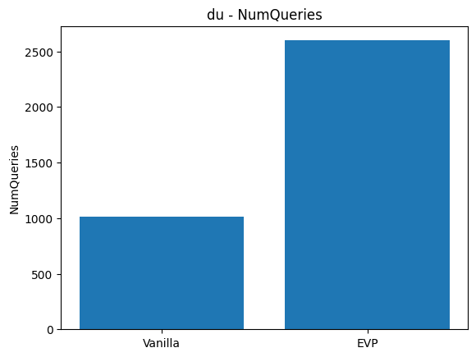

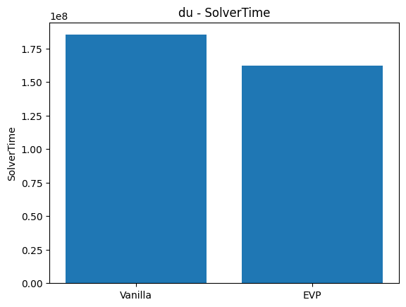

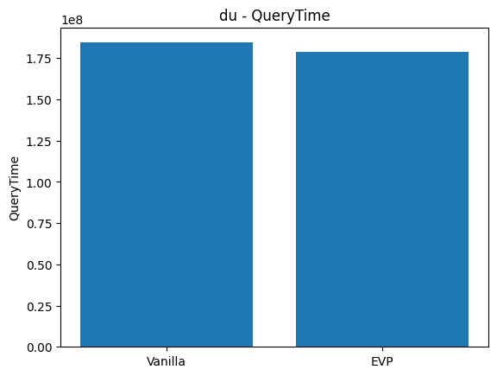

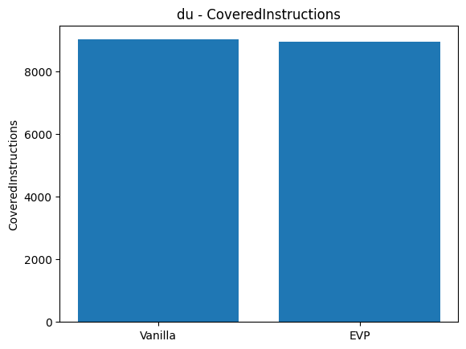

|  |  |  |  |  |  |
| --- | --- | --- | --- | --- | --- |
|  | **Metric** | **Vanilla** | **EVP** | **Difference** | **% Difference** |
| **0** | NumQueries | 1010.0 | 2598.0 | 1588.0 | 157.227723 |
| **1** | NumQueryConstructs | 80261.0 | 412879.0 | 332618.0 | 414.420453 |
| **2** | SolverTime | 185263064.0 | 162230564.0 | -23032500.0 | -12.432322 |
| **3** | QueryTime | 184386011.0 | 178803189.0 | -5582822.0 | -3.027790 |
| **4** | CexCacheTime | 185102907.0 | 162068017.0 | -23034890.0 | -12.444370 |
| **5** | CoveredInstructions | 9019.0 | 8946.0 | -73.0 | -0.809402 |
| **6** | UncoveredInstructions | 36996.0 | 37069.0 | 73.0 | 0.197319 |
| **7** | NumStates | 772.0 | 725.0 | -47.0 | -6.088083 |
| **8** | Instructions | 1987596.0 | 1961664.0 | -25932.0 | -1.304692 |
| **9** | WallTime | 187427002.0 | 182440217.0 | -4986785.0 | -2.660655 |